User Guide



Vidyo Meeting Room

Table of Contents:

**1** **Vidyo Meeting Login** 3

1.1 Vidyo Meeting Sign In Information: 3

**2** **Vidyo Meeting Room** 4

2.1 Vidyo Meeting Room details: 5

**3** **Logout Meeting:** 6

# **Vidyo Meeting Login**

When you access the Vidyo.io Video Meeting URL, you are prompted to sign in.

## Vidyo Meeting Sign In Information:

The Vidyo.io Join Vidyo Meeting page will look similar to this:

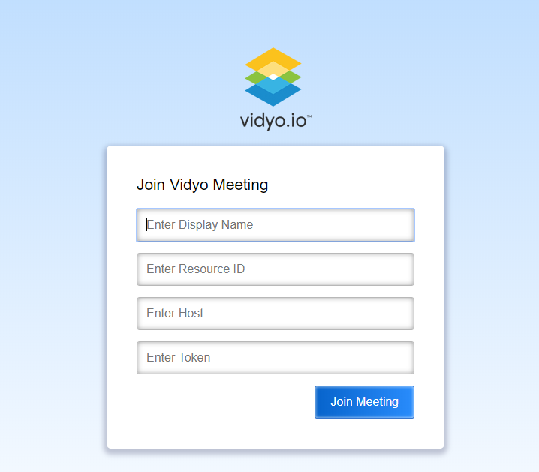

The Vidyo Join Meeting page allows the users to Join Meeting. It has four fields, the Display Name, Resource ID, Host and the Token. The inputs will be verified when you click the “Join Meeting” button and once the verification is complete, the user will proceed to the Meeting Room.

If the user enters invalid Display Name or Resource ID or Host or Token, appropriate error message is displayed to the user.

# **Vidyo Meeting Room**

Upon successful Join to the Meeting, Meeting Room page is displayed to the user with the participants already joined in the same meeting

The Vidyo Meeting Room page will look similar to this:

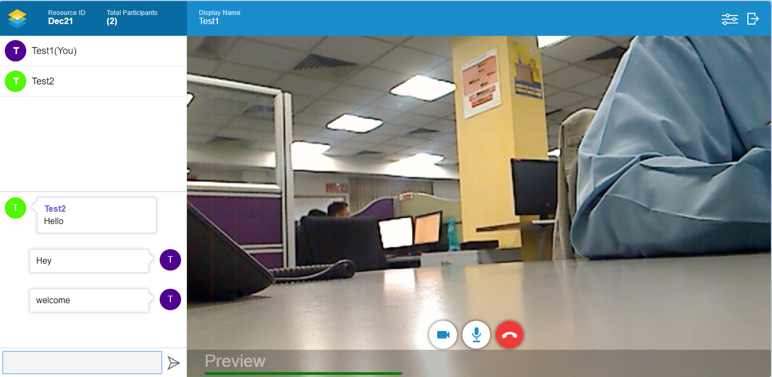

## Vidyo Meeting Room details:

Header section displays the Resource ID (currently joined Meeting), Total Participants (No of Participants currently joined the Meeting) in the left side.

Below the Header, on the left side, list of Participants in the meeting (Display Names) currently joined the meeting are displayed in the top part. Bottom part in the left side displays the Text Chat area where Meeting Participants can send text messages

On the right side, participant’s videos (if camera available and allowed) are displayed.

On the bottom of the Meeting room screen, 3 buttons are displayed. Camera button to turn On/Off the video for the user, Microphone button to Mute/Unmute the audio and End Call button to end the meeting.

On the right side, Display Name (currently Joined In user’s display name), Settings and Logout button are displayed.

**Settings Screen:**

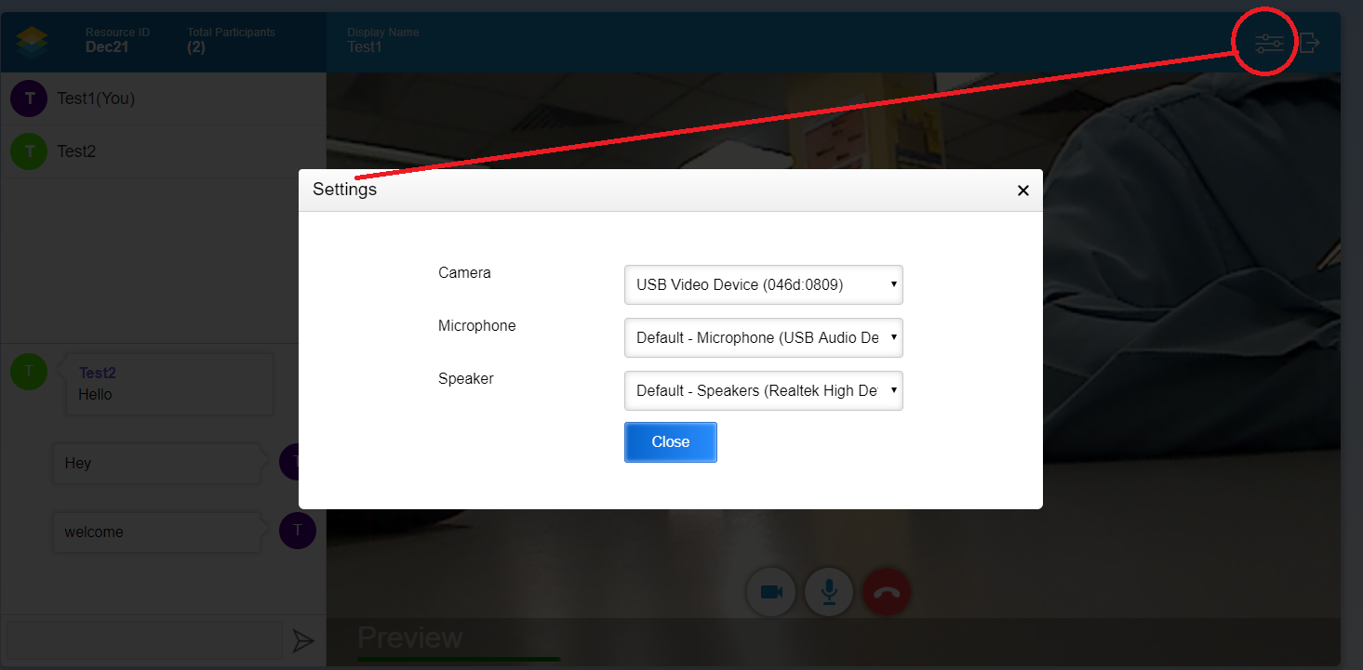

Settings screen will have the options to choose Camera, Microphone and Speaker.

# **Logout Meeting:**

User can logout of the meeting by clicking Logout button displayed at the top right corner of the Meeting Room screen.

When user clicks Logout button, user is logged out of the current Meeting and returned to the Login Page.

